* 1. 

Hands-On Lab

Silverlight 4 – Out-of-Browser with COM Interop

**Contents**

Introduction 3

Exercise 1 - Creating an Out-of-Browser Application 4

Task 1 – Elevate Privileges and Handle Out-of-Browser Events 5

Task 2 – Integrating Silverlight with Excel and Outlook 8

Exercise 2 - Signing a XAP Assembly and Performing Silent Installations 14

Task 1 – Signing a XAP File 15

Task 2 – Performing a Silent Installation 16

Conclusion 18

Introduction

* 1. Silverlight 4 added many features for LOB (Line of Business) applications. While Silverlight 3 introduced the ability to run a Silverlight application without a browser host (Out-of-Browser), Silverlight 4 adds features including the ability to elevate the application's security permissions in order to gain access to local resources such as the file system, the ability to use native integration and COM automation.
  2. In this Lab we'll build an out-of-browser application, see how to elevate permissions and learn how to manipulate COM objects to control applications such as Outlook and Excel. We'll add code to send records in a DataGrid control into Excel and even sync changes made in Excel with the DataGrid. In addition, we'll also learn how to load data from Silverlight into an Outlook email message, change the chrome of an out-of-browser application, sign a XAP to make it trusted and perform a silent installation of a XAP file.
  3. Estimated completion time for this lab is 60 minutes.

Exercise 1 - Creating an Out-of-Browser Application

* 1. In this exercise we'll see how to enable an application to run out-of-browser with elevated privileges. We'll also handle checking for application updates and detecting if the application is closing. Once those tasks are completed code will be added to automate Excel and Outlook.
  2. Start Visual Studio 2010
  3. On the **File** menu click **Open** 🡪 **Project/Solution…**
     1. Alternatively, from Visual Studio Start Page click “**Open Project…**”
  4. At the “Open Project” dialog navigate to the Lab installation folder
  5. Navigate to the “Source\Ex01\begin” folder
  6. Click the “OOBWindows.sln” file followed by the “**Open**” button
  7. Take some time to familiarize yourself with the application
     1. Points of interest here are:
        + MainPage.xaml
        + MainPage.xaml.cs
        + WindowClosing.xaml
        + WindowClosing.xaml.cs
        + DataHelper.cs
  8. Set the **OOBWindows.Web** project as the startup project by right clicking the project in the Solution Explorer and selecting “Set as Startup Project”

Task 1 – Elevate Privileges and Handle Out-of-Browser Events

* 1. In this task you will modify the Silverlight project's properties and add code to the application to handle specific out-of-browser events. You'll also create a ChildWindow that will prompt the user to install the application.
  2. If you have not opened the project open it now (see previous section for instructions)
  3. Right-click on the OOBWindows project in the Solution Explorer and select Properties from the menu.
  4. Go to the Silverlight tab and check the **Enable running application out of the browser** checkbox.
  5. Click the **Out-of-Browser Settings** button and check the **Require elevated trust when running outside the browser** checkbox. This will allow the application to access specific features such as COM Interop once it's running out-of-browser.
  6. The Window Style drop-down in the Out-of-Browser Settings dialog allows different window styles to be selected including Default, No Border, Single Border and Borderless Round Corners (see Figure 1).
     1. 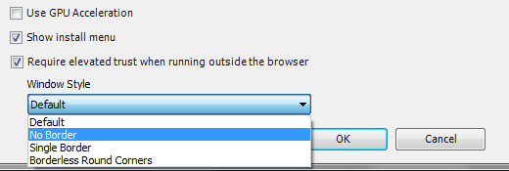
     2. Figure 1
     3. Out-of-Browser Settings Dialog
  7. Select the **Borderless Round Corners** item from the Window Style drop-down and click the OK button to close the project's properties window.
  8. Open MainPage.xaml.cs in the code editor window.
  9. Add a field of type Window named mainWindow:
     1. C#
     2. Window mainWindow;
  10. Within the MainPage_Loaded method add the following code to check if the application is running out-of-browser:
      1. C#
      2. mainWindow = Application.Current.MainWindow;
      3. if (Application.Current.IsRunningOutOfBrowser)
      4. {
      5. }
      6. else
      7. {
      9. }
  11. Within the **if** statement add code to handle the MainWindow object's Closing event:
      1. C#
      2. mainWindow.Closing += (s, args) =>
      3. {
      4. WindowClosing win = new WindowClosing();
      5. win.Closed += (sen, winArgs) =>
      6. {
      7. if (win.DialogResult.Value) args.Cancel = true;
      8. };
      9. win.Show();
      10. };
  12. Immediately under the code added in the previous step add code to check if a new update is available on the server. If an update is found notify the user.
      1. C#
      2. Application.Current.CheckAndDownloadUpdateCompleted += (s, args) =>
      3. {
      4. if (args.UpdateAvailable) MessageBox.Show("Application has been updated." +
      5. "Please close and re-launch the application to pick up the changes.");
      6. };
      7. Application.Current.CheckAndDownloadUpdateAsync();
  13. Now that all of the out-of-browser events have been handled we'll add a ChildWindow that will display when the application first loads. The ChildWindow will let the user know that they need to install the application and provide an install button that they can click.
  14. Right-click on the OOBWindows project and select Add 🡪 New Item from the menu.
  15. Select **Silverlight Child Window** and give it a name of **InstallWindow.xaml**.
  16. Remove the 2 buttons that are currently in the **InstallWindow.xaml** file.
  17. Add the following code within the existing Grid control:
      1. XAML
      2. <StackPanel>
      3. <TextBlock Text="This application must be installed out-of-browser to run.   
          Please click the Install Button and then exit the application."   
          TextWrapping="Wrap" Margin="10"/>
      4. <Button Content="Install Application" HorizontalAlignment="Center"   
          FontSize="14" Click="Button_Click" Margin="50" />
      5. </StackPanel>
  18. Double-click on the **Install Application** button in the XAML designer to create a click event handler for it.
  19. Add the following code within the button's click event handler in InstallWindow.xaml.cs:
      1. C#
      2. if (App.Current.InstallState != InstallState.Installing)
      3. {
      4. App.Current.InstallStateChanged += (s, args) =>
      5. {
      6. if (App.Current.InstallState == InstallState.Installed)
      7. {
      8. MessageBox.Show("Application installed! Please close your " +
      9. "browser and run the application from your desktop " +
      10. "or Start menu.");
      11. }
      12. };
      13. App.Current.Install();
      14. }
  20. Go back to MainPage.xaml.cs, locate MainPage_Loaded and add the following code into the **else** block to show the InstallWindow to the user if the application is not running out-of-browser:
      1. C#
      2. InstallWindow win = new InstallWindow();
      3. win.Closed += (s, args) =>
      4. {
      5. this.LayoutRoot.Visibility = Visibility.Collapsed;
      6. };
      7. win.Show();
  21. Run the application by pressing F5 and the ChildWindow should display. Click the Install Application button to take the application out-of-browser. Close the browser and the out-of-browser application that is running.
  22. Right-click on the OOBWindows project and select "Set as Startup Project" from the menu.
  23. Go to the OOBWindows properties window, select the Debug tab and ensure that the **Installed out-of-browser application** radio button is selected. Close the properties window once you're done.
  24. Press F5 again to run the application and note that the out-of-browser application starts instead of the browser-based application. Looking at the application you'll see a DataGrid containing customer data as well as buttons that allow users to export the data to Excel or email the data using Outlook. Close the application before moving on to the next task.
      1. 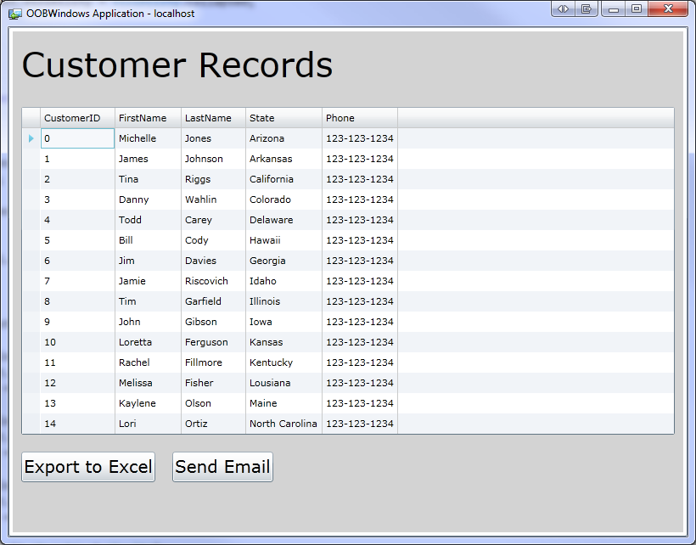
      2. Figure 2
      3. Running the out-of-browser application

Task 2 – Integrating Silverlight with Excel and Outlook

* 1. Silverlight 4 allows out-of-browser applications with elevated privileges to interact with desktop applications such as Excel and Outlook. In this task we'll add code to instantiate Excel through COM Interop and add data from a DataGrid to a worksheet. We'll also see how to interact with Outlook and dynamically add data from the Silverlight application into an email message.
  2. Right-click on the OOBWindows project in the Solution Explorer and select Add Reference from the menu.
  3. Select the **Microsoft.CSharp** assembly and click OK. This assembly supports the new C# 4.0 **dynamic** keyword which we'll use to create Excel and Outlook objects through COM Interop.
  4. Open MainPage.xaml.cs in the code editor and add a reference to the System.Runtime.InteropServices.Automation namespace at the top of the MainPage.xaml.cs file. This namespace contains the AutomationFactory class used to interact with COM-based applications such as Excel.
     1. C#
     2. using System.Runtime.InteropServices.Automation;
  5. Locate the **LaunchExcel** method and add the following code to check if Excel is running already by calling AutomationFactory.GetObject. If it's not running a new Excel object will be created using AutomationFactory.CreateObject.
     1. C#
     2. string excelName = "Excel.Application";
     3. try
     4. {
     5. //See if Excel is already running
     6. excel = AutomationFactory.GetObject(excelName);
     7. }
     8. catch
     9. {
     10. excel = AutomationFactory.CreateObject(excelName);
     11. }
  6. Once the object is created Excel needs to be made visible to the end user and a workbook needs to be created. Add the following code into LaunchExcel below the code added in the previous step:
     1. C#
     2. if (excel == null) excel = AutomationFactory.CreateObject("Excel.Application");
     3. excel.Visible = true;
     4. dynamic workbook = excel.workbooks;
     5. workbook.Add();
     6. dynamic sheet = excel.ActiveSheet;
  7. The data from the existing DataGrid needs to be exported to Excel. To accomplish that task we'll iterate through the DataGrid's ItemSource and programmatically create cells that are added into the Excel worksheet. Add the following code immediately below the code added in the previous step:
     1. C#
     2. dynamic cell = null;
     3. int i = 1;
     4. foreach (Customer cust in dg.ItemsSource)
     5. {
     6. cell = sheet.Cells[i /*row*/, 1 /*col*/];
     7. cell.Value = cust.FirstName;
     8. cell.ColumnWidth = 25;
     9. cell = sheet.Cells[i, 2];
     10. cell.Value = cust.LastName;
     11. cell.ColumnWidth = 25;
     12. cell = sheet.Cells[i, 3];
     13. cell.Value = cust.Phone;
     14. cell.ColumnWidth = 25;
     15. cell = sheet.Cells[i, 4];
     16. cell.Value = cust.State;
     17. cell.ColumnWidth = 25;
     18. i++;
     19. }
  8. If the end user changes data in the Excel spreadsheet we'd like to sync it automatically with the Silverlight DataGrid. Add the following code (below the previous code) which handles Excel's SheetChange event:
     1. C#
     2. if (firstTime)
     3. {
     4. excel.SheetChange += new SheetChangedDelegate(sheetChangedEventHandler);
     5. string name = sheet.Name;
     6. firstTime = false;
     7. }
  9. As data changes in the Excel spreadsheet we want to sync it with the application's DataGrid. Add a sheetChangedEventHandler method to walk through the Excel cells and update the DataGrid's ItemsSource with any changes. Once the DataGrid is updated we'll show a NotificationWindow to the end user. Add the event handler method below into the MainPage.xaml.cs class.
     1. C#
     2. private void sheetChangedEventHandler(dynamic excelSheet, dynamic rangeArgs)
     3. {
     4. dynamic sheet = excelSheet;
     5. string name = sheet.Name;
     6. dynamic range = rangeArgs;
     7. dynamic rowvalue = range.Row;
     8. IEnumerable<Customer> custs = dg.ItemsSource as IEnumerable<Customer>;
     9. int len = custs.Count();
     10. Customer[] newEntities = new Customer[len];
     11. dynamic col1range = sheet.Range("A1:A" + len.ToString());
     12. dynamic col2range = sheet.Range("B1:B" + len.ToString());
     13. dynamic col3range = sheet.Range("C1:C" + len.ToString());
     14. dynamic col4range = sheet.Range("D1:D" + len.ToString());
     15. for (int i = 0; i < len; i++)
     16. {
     17. dynamic item1 = col1range.Item(i + 1);
     18. dynamic item2 = col2range.Item(i + 1);
     19. dynamic item3 = col3range.Item(i + 1);
     20. dynamic item4 = col4range.Item(i + 1);
     21. Customer newEntity = new Customer();
     22. newEntity.CustomerID = i;
     23. newEntity.FirstName = item1.Value;
     24. newEntity.LastName = item2.Value;
     25. newEntity.Phone = item3.Value;
     26. newEntity.State = item4.Value;
     27. newEntities[i] = newEntity;
     28. }
     29. dg.ItemsSource = newEntities;
     30. dg.SelectedIndex = Convert.ToInt32(rowvalue) - 1;
     31. //Show NotificationWindow
     32. NotificationWindow win = new NotificationWindow();
     33. Grid grid = new Grid { Background = new SolidColorBrush(Colors.Yellow) };
     34. grid.Children.Add(new TextBlock { FontSize = 20, Text = "Customers Modified",   
          HorizontalAlignment = HorizontalAlignment.Center,   
          VerticalAlignment=VerticalAlignment.Center });
     35. win.Content = grid;
     36. win.Show(3000);
     37. }
  10. The user may want to email the data in the DataGrid to one or more people in their company. This can be done by converting the data to HTML and then embedding it in an Outlook email message. Open the DataHelper class in the code editor window and look through the method named **GetCustomersAsHtmlTable**. Notice that the method simply iterates through a collection of Customer objects and converts the data into HTML that can be embedded in an email message.
  11. Close the DataHelper.cs class in the code editor.
  12. Go back to MainPage.xaml.cs and locate the **CreateEmail** method. This method will use the AutomationFactory class's GetObject method to check if Outlook is already running or not. If it isn't AutomationFactory.CreateObject will be called. Once Outlook is available the code will create an email message and assign values to the To, Subject and Body properties. Add the following code into the **CreateEmail** method to handle the creation an Outlook message object using COM Interop:
      1. C#
      2. string outlookName = "Outlook.Application";
      3. try
      4. {
      5. //See if Outlook is already running
      6. outlook = AutomationFactory.GetObject(outlookName);
      7. }
      8. catch
      9. {
      10. outlook = AutomationFactory.CreateObject(outlookName);
      11. }
      12. dynamic mailItem = outlook.CreateItem(0);
      13. mailItem.Display();
      14. string msgBody = "<P>Customer Records</P>";
      15. msgBody += "<P>" + DataHelper.GetCustomersAsHtmlTable() + "</P>";
      16. mailItem.To = "BigBoss;";
      17. mailItem.Subject = "Updated Customer Records";
      18. mailItem.HTMLBody = msgBody;
  13. Build the project by going to Build 🡪 Rebuild Solution on the Visual Studio menu.
  14. Run the application by clicking the icon on the desktop (or in the Start menu if you didn't install it with the desktop option). If you're notified that changes have been made close the application and re-start it to pick up the changes.
  15. Once the application opens click the **Export to Excel** button which will show the data in a new Excel spreadsheet. Make a change in the spreadsheet and notice how the notification window appears in the lower-right corner of the desktop and how any changes are updated in the application's DataGrid.
  16. Click the **Send Email** button and notice how the DataGrid data is converted into HTML and embedded in the Outlook email message.
      1. 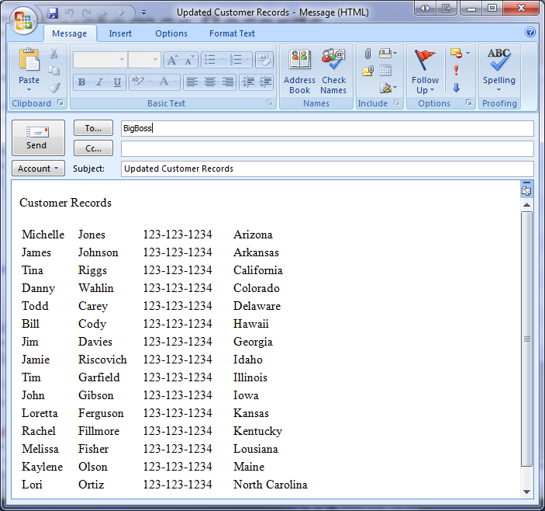
      2. Figure 3
      3. Sending an Email from Silverlight using COM Interop
  17. Right-click on the application and select **Remove this application** from the menu.

Exercise 2 - Signing a XAP Assembly and Performing Silent Installations

* 1. The introduction of elevated trust out-of-browser applications in Silverlight 4 will enable developers to push the limits of what was previously capable in the plug-in and take advantage of platform privileges that are in-accessible to sandboxed Silverlight apps. Along with this privilege comes more risk for an application to do harm to an end user’s machine. XAP signing is introduced to offer protection from and educate end user’s on applications that may be potentially harmful.
  2. XAP signing reassures end users of the authenticity of an application’s publisher and that the code has not been tampered with.  It has an effect on the app install experience and restricts the scenarios for update of elevated trust applications. Upon installation of an elevated trust application end user’s will be presented with dialogs as shown in Figure 4 and Figure 5.

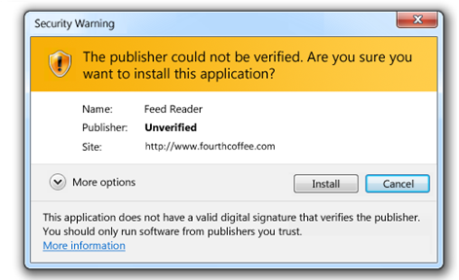

* + 1. Figure 4
    2. Unverified Publisher Install Dialog
    3. 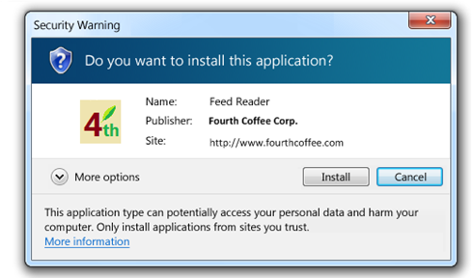
    4. Figure 5
    5. Verified Publisher Install Dialog
  1. A XAP can be signed post-build using the SignTool.exe command line tool which is present in the Windows SDK, as part of Visual Studio 2010 and a handful of other packages. XAPs must be signed using code signing certificates.
  2. In addition to XAP signing, Silverlight out-of-browser applications can also be installed silently using sllauncher.exe. This allows applications to be installed using a .bat file or from a CD or DVD.   
     We'll create a silent installer .bat file in Task 2 of this exercise.

Task 1 – Signing a XAP File

* 1. In this task you'll go through the process of signing a XAP file using the SignTool.exe command line tool.
  2. Locate the Visual Studio Command Prompt by going to Start 🡪 All Programs 🡪 Visual Studio 2010 🡪 Visual Studio Tools 🡪 Visual Studio Command Prompt.
  3. Right-click on Visual Studio Command Prompt and select **Run as administrator**.
  4. Type the following into the command window and then press [Enter] to go back to the root of the c drive:

**cd \**

* 1. Type the following into the command window and press [Enter] to create a self-signed root certificate using makecert.exe. If you get any type of arguments error after hitting [Enter] double-check what you typed against the text below.

**makecert –n “CN=My Root Certificate Authority” –r –a sha1–sr LocalMachine –sky signature   
–sv OOBRootCA.pvk OOBRootCA.cer**

* 1. When prompted for a password use **P@ssw0rd**. You'll be prompted to enter the password a few times – enter the same password each time.
  2. Type the following into the command window and press [Enter] to create a child certificate that can be used for code signing. It will be signed by the root certificate created earlier.

**makecert -sv OOBCodeSigningCA.pvk -iv OOBRootCA.pvk -n "CN=OOB Code Signing CA"   
-ic OOBRootCA.cer OOBCodeSigningCA.cer**

* 1. Enter **P@ssw0rd** for the password when prompted.
  2. Generate a PFX file (contains the password and the private key in one file for convenience). Note that the same password entered earlier is used. Enter the following into the command window and press [Enter]:

**pvk2pfx –pvk OOBCodeSigningCA.pvk –spc OOBCodeSigningCA.cer –pfx OOBCodeSigningCA.pfx   
–po P@ssw0rd**

* 1. Enter **P@ssw0rd** for the password when prompted.
  2. Copy all of the certificate files that were generated from the root c:\ folder to the lab's Ex02\begin\OOBWindows.Web\ClientBin folder.
  3. Navigate to the **Ex02\begin\OOBWindows.Web\ClientBin** folder in the Visual Studio Command Prompt window (example command syntax: cd [Lab Folder Path]\Source\Ex02\begin\OOBWindows.Web\ClientBin).
  4. Type the following into the command window and press [Enter] to sign the XAP file:

**signtool sign /v /f OOBCodeSigningCA.pfx /p P@ssw0rd OOBWindows.xap**

* 1. If the XAP was successfully signed you'll see verbiage similar to the following in the command window.
     1. 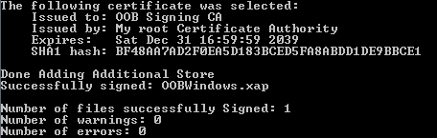
     2. Figure 6
     3. Signing a XAP using signtool.exe

Task 2 – Performing a Silent Installation

* 1. In this task you will create a .bat file that can be used to perform a silent installation using sllauncher.exe. Silent installs are useful for installing a Silverlight application directly on a machine using a .bat file or from a CD or DVD.
  2. Open Windows Explorer and navigate to the lab's Source\Ex02\begin\OOBWindows.Web\ClientBin folder.
  3. Right-click in the ClientBin folder and select New 🡪 Text Document from the menu. Name the document **SilentInstaller.bat**.
  4. Start Visual Studio 2010 (close the existing solution if one is already open).
  5. On the **File** menu click **Open** 🡪 **Project/Solution…**
     1. Alternatively, from Visual Studio Start Page click “**Open Project…**”
  6. At the “Open Project” dialog navigate to the Lab folder
  7. Navigate to “Source\Ex02\begin” folder
  8. Click the “OOBWindows.sln” file and then click the “**Open**” button
  9. Right-click the **OOBWindows.Web** project and select "Start as Startup Project" from the menu.
  10. Press F5 to run the project.
  11. Once the browser loads, note the port number that is being used in the URL.
  12. Go back to Windows Explorer, right-click on **SilentInstaller.bat**, and select Edit from the menu.
  13. Enter the following into the **SilentInstaller.bat** file and save the file when done. Adjust the /install switch path to point to the location of the OOBWindows.xap file and the URL defined using the /origin switch to use the port where your XAP file is hosted when the application is run in the browser.

**"C:\Program Files\Microsoft Silverlight\sllauncher.exe" /install:"C:\[Path to Lab Folder]\Source\Ex02\end\OOBWindows.Web\ClientBin\OOBWindows.xap" /origin:"http://localhost:49786/ClientBin/OOBWindows.xap" /shortcut:desktop+startmenu /overwrite**

* 1. Click the SilentInstaller.bat file in Windows Explorer to execute it. The OOBWindows application should be installed and an icon for it should show on the desktop.

Conclusion

In this lab we learned about the new features Silverlight 4 offers for out of browser applications. We saw how to create an out-of-browser application, configure it to use elevated permissions, and use COM automation from Silverlight to manipulate Word and Excel. We've also seen how a XAP file can be signed using SignTool.exe and how a XAP can be installed silently using sllauncher.exe